The Lymphatic and Immune System

Pluripotent Stem Cells

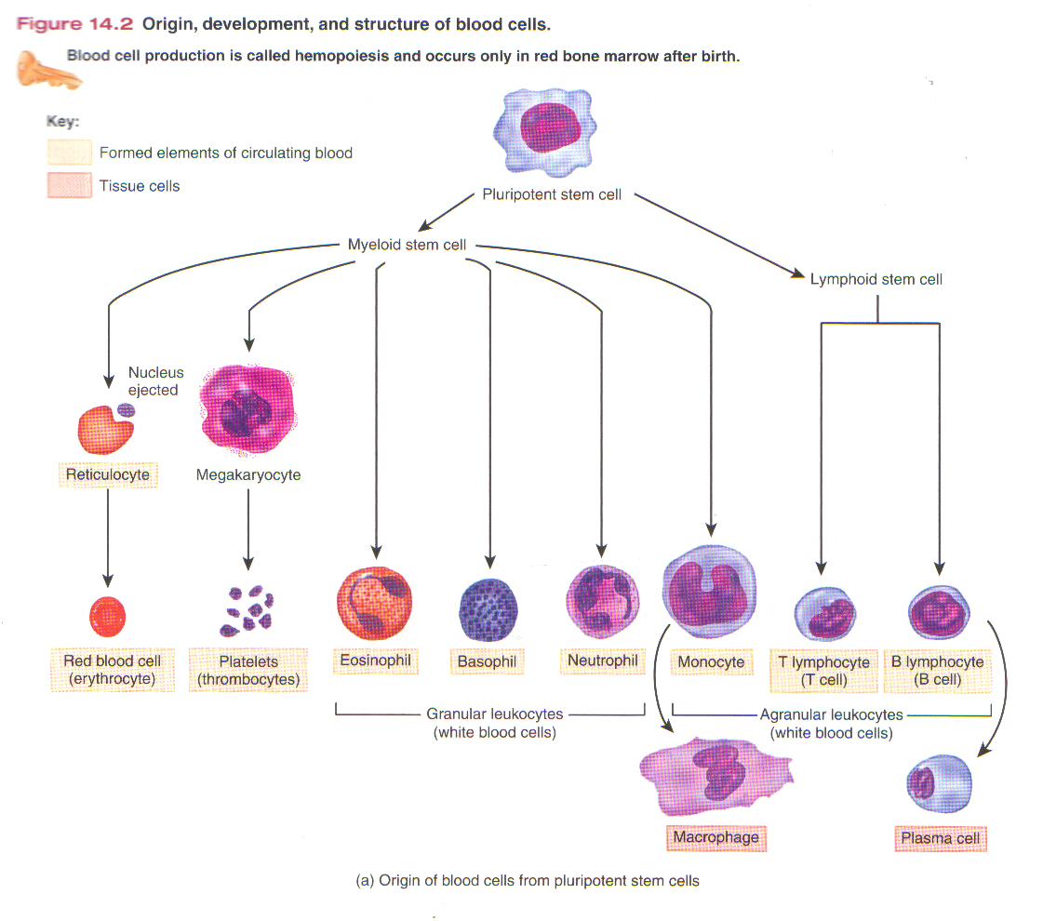

Pluripotent stems cells have the capacity to develop into several different types of cells in response to stimulation by specific hormones.

- Myeloid stem cells: begin their development in red bone marrow and differentiate into several types of cells from which red blood cells, platelets, eosinophils, basophils, neutrophils, and monocytes develop

- Lymphoid stem cells: begin their development in red bone marrow but complete it in lymphatic tissues. They differentiate into cells from which the T and B lymphocytes develop.
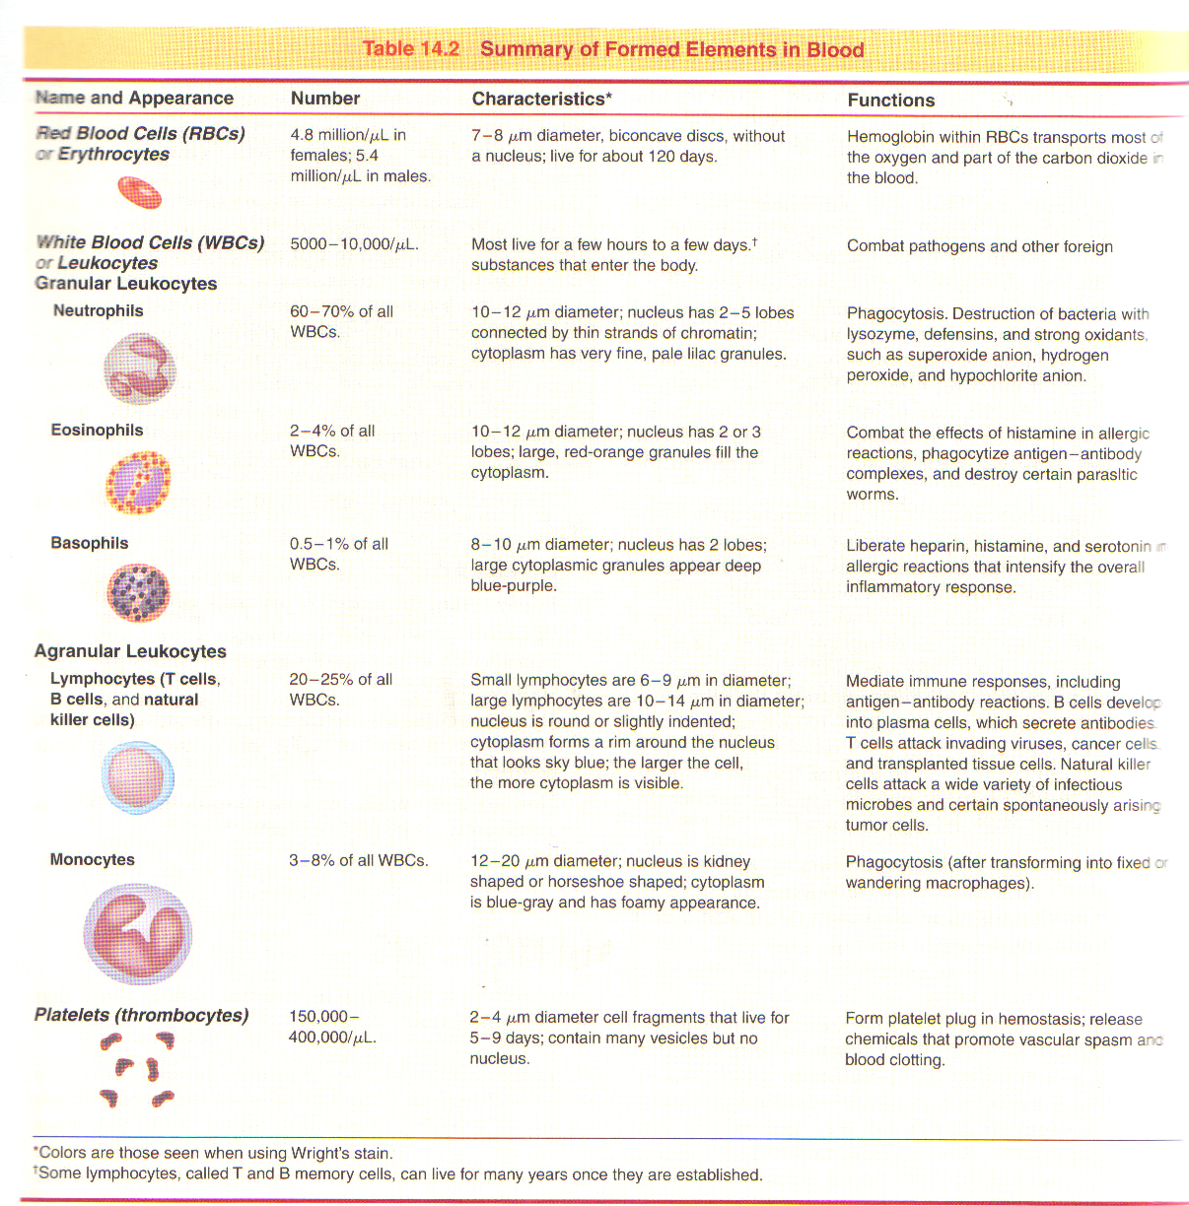

Pathogens: disease-producing microbes such as bacteria and viruses.

Resistance: the ability to use our body’s defenses to ward off damage or disease
- Nonspecific resistance/innate defense
  - Present at birth
  - Include mechanisms that provide immediate but general protection against invasion by a wide range of pathogens
  - Mechanical and chemical barriers of the skin and mucous membranes provide the first line of defense
- Specific resistance/ immunity
  - Develops in response to contact with a specific invader
  - Delayed response and involves activation of specific lymphocytes (B cells & T cells) that combat a specific invader

Susceptibility: vulnerability or lack of resistance

Lymphatic and immune system: consists of lymph, lymphatic vessels, a number of structures and organs containing lymphatic tissue, and red bone marrow.

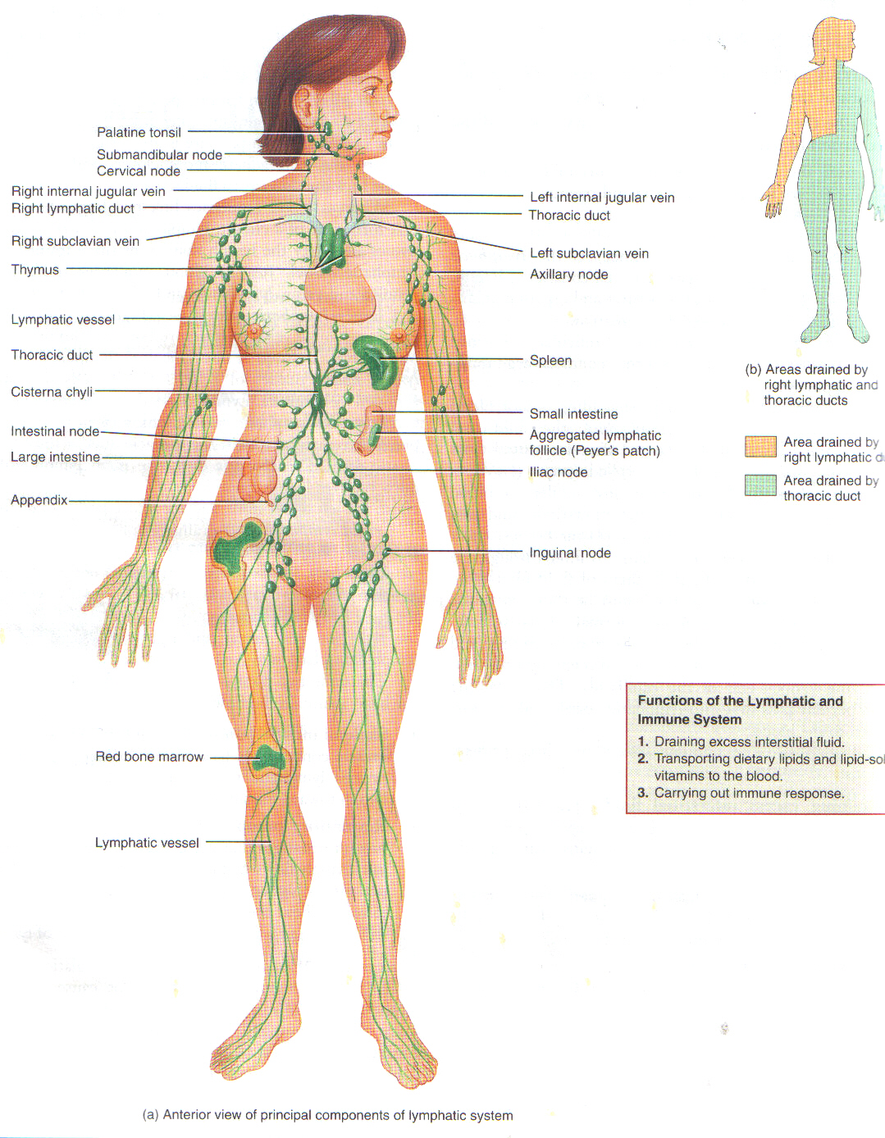

Lymphatic tissue: contains large number of lymphocytes

Interstitial fluid: components of blood plasma that filters out of blood capillaries; the fluid that surrounds the cells of body tissues

Lymph: interstitial fluid that enters into lymphatic vessels

Functions of Lymphatic and Immune System:
- Draining excess interstitial fluid and return to blood; maintains fluid balance
- Transports dietary lipids absorbed by the gastrointestinal tract to the blood
- Carrying out immune responses: lymphatic tissue initiates highly specific responses directed against particular microbes or abnormal cells

Circulation:
- Lymphatic capillaries are the beginning of lymphatic vessels; located in the spaces between cells; allows interstitial fluid to flow into them but not out
- Lymphatic capillaries unite to form larger lymphatic vessels: thinner walls and more valves than veins
- Lymph nodes: masses of B cells and T cells that are surrounded by a capsule
- Two main channels
  - Thoracic duct: receives lymph from the left side of the head, neck, and chest, the left upper limb, and the entire body below the ribs; empties into the left subclavian vein then SVC
  - Right lymphatic duct: drains lymph from the upper right side of the body; empties into the right subclavian vein then SVC

Sequence of fluid flow
- Blood capillaries (blood plasma) →
- Interstitial spaces (interstitial fluid) →
- Lymphatic capillaries (lymph) →
- Lymphatic vessels and lymph nodes (lymph) →
- Lymphatic ducts (lymph) →
- Subclavian veins (blood plasma)

Edema: an excessive accumulation of interstitial fluid in tissue spaces

Lymphatic Organs and Tissues:
Thymus: contains large numbers of T cells: immature T cells migrate from red bone marrow to the thymus, where they multiply and begin to mature; mature T cells leave the thymus via the blood and carried to lymph nodes, the spleen, and other lymphatic tissue.

Lymph Nodes: filter lymph which enters through an afferent lymphatic vessel; foreign substances are trapped within the spaces between cells; macrophages destroy some by phagocytosis, and lymphocytes destroy others by a variety of immune responses; exits through the efferent vessel.
Spleen: the largest single mass of lymphatic tissue in the body
- White pulp: lymphatic tissue, consisting mostly of lymphocytes and macrophages
  - B cells and T cells carry out immune responses, while macrophages destroy pathogens by phagocytosis
- Red pulp: consists of blood filled venous sinuses and cords of splenic tissue consisting of red blood cells, macrophages, lymphocytes, plasma cells, and granular leukocytes
  - Removal by macrophages of worn out or defective blood cells and platelets
  - Storage of platelets
  - Production of blood cells during fetal life

Tonsils: masses of lymphatic tissue not surrounded by a capsule; participate in immune responses against inhaled or ingested foreign substances
- Pharyngeal tonsil (adenoid): posterior wall of the upper part of the throat
- Palatine tonsils: at the back of the mouth
- Lingual tonsils: base of the tongue

Nonspecific Resistance: Innate Defenses
- Present at birth
- Offer immediate protection against a wide variety of pathogens and foreign substances

- First Line of Defense:
- Physical Barriers:
    - Epidermis of skin: forms a physical barrier to the entrance of microbes
    - Mucous membranes: inhibit the entrance of many microbes
    - Mucus: traps microbes in respiratory and gastrointestinal tracts
    - Hairs: filter out microbes and dust in nose
    - Cilia: trap and remove microbes and dust from upper respiratory tract
    - Lacrimal apparatus: tears dilute and wash away irritating substances and microbes
    - Saliva: washes microbes from surfaces of teeth and mucous membranes of mouth
    - Urine: washes microbes from urethra
    - Body reflexes: (coughing, vomiting, etc.)

- Chemical Barriers:
    - Sebum: forms a protective acidic film over the skin surface that inhibits growth of many microbes
    - Lysozyme: antimicrobial substance in perspiration, tears, saliva, nasal secretions, and tissue fluids
    - Gastric juices: destroys most bacteria and toxins in stomach
    - Vaginal secretions: slight acidity discourages bacterial growth; flush microbes out of vagina

  - Antimicrobial Proteins:
- Interferons: proteins produced by lymphocytes, macrophages, and fibroblasts when infected with a virus; IFNs diffuse to uninfected areas and stimulate synthesis of proteins that interfere with viral replication.
- Complement system: a group of normally inactive proteins in blood plasma; when activated enhance certain immune, allergic, and inflammatory reactions; cause:
    - Cytolysis: create holes in the plasma membrane of the microbe causing the contents to leak out
    - Chemotaxis: the chemical attraction of phagocytes to a site
    - Opsonization: bind to the surface of a microbe and promote phagocytosis

- Second line of Defense: Internal Defenses
  - Natural Killer Cells: kill a vide variety of microbes and certain tumor cells by causing cellular destruction by releasing proteins that destroy the target cell’s membrane
  - Phagocytes: perform the ingestion of microbes or other particles; two main types: neutrophils and monocytes/macrophages
  - Inflammation: a nonspecific, defensive response of the body to tissue damage.
    - Disposes of microbes, toxins, or foreign material at the site of injury, prevent their spread to other tissue, and prepare the site for tissue repair.
    - Signs: redness, pain, heat, and swelling
    - Changes in blood vessels:
      - Vasodilation: increase in the diameter; allows more blood to flow to the damaged area and helps remove microbial toxins and dead cells
      - Increased permeability: substances normally restrained are permitted to pass; permits antibodies and clot forming chemicals to enter the injured site.

  - Fever: elevated body temperature due to reset hypothalamic thermostat; bacterial toxins trigger release of fever causing substances such as interleukin-1. Fever intensifies the effects of interferons, inhibits the growth of some microbes, and speeds up body reactions that aid repair.

Specific Resistance: Immunity

Immunity: the production of specific types of cells or specific antibodies to destroy a particular antigen

Antigen: any substance such as microbes, foods, drugs, pollen, or tissue that the immune system recognizes as foreign; causes plasma cells to produce specific antibodies and or specific T cells that react with it

Antibodies (immunoglobulins): contain four polypeptide chains, at the tips of the chains are variable regions (sequence if amino acids varies for each antibody) that are the antigen-binding site- the port that fit and bind to a particular antigen.
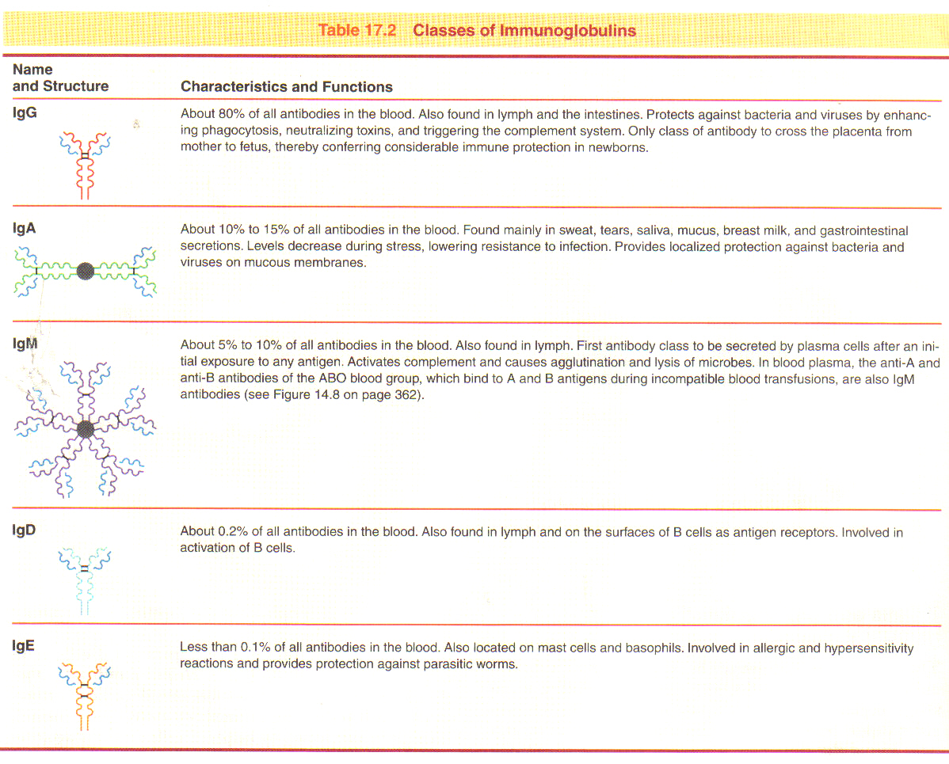

Major histocompatibility complex (MHC) proteins: “self antigens” located on most body cells help T cells recognize that an antigen is foreign.

Cells that carry out immune responses are lymphocytes called B cells and T cells
- Both originate in red bone marrow
- Before leaving place of maturity, they begin to make distinctive proteins that are inserted into their plasma membrane- some of these proteins function as antigen receptors (molecules capable of recognizing and binding to specific antigens).

B cells:
- Complete their development in bone marrow
- Antibody-mediated immune responses: B cells change into plasma cells, which synthesize and secrete antibodies.
  - A given antibody can bind to and inactivate a specific antigen
- Can recognize and bind to antigens in lymph, interstitial fluid, or blood plasma

T Cells:
- Migrate from bone marrow to the thymus where they mature
- Cell-mediated immune response: T cells directly attack the invading antigen
- Only recognize fragments of antigens that are presented together with a MHC protein.
- Other T cells aid both cell-mediated and antibody-mediated immune responses

Processing and Presenting Antigens
For an immune response to occur, B cells and T cells must recognize that a foreign antigen is present.

Antigen-presenting cells (APCs): macrophages, B cells, and dendritic cells that prepare antigens for presentation
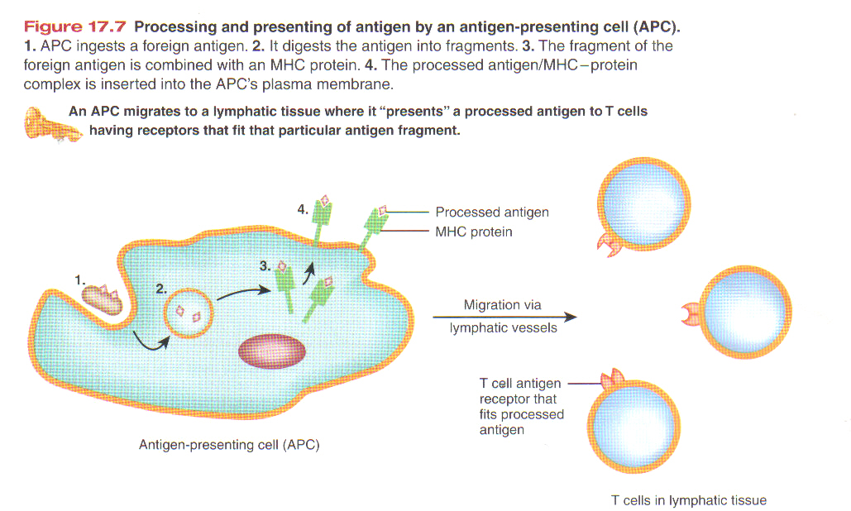

- T cells and cell-mediated immunity: the presentation of an antigen by APCs informs T cells that intruders are present in the body.
- T cells becomes activated only if its antigen receptor binds to the foreign antigen and at the same time receives a second stimulating signal (costimulation), a common costimulator is interleukin-2.
- Once a T cell is activated, it enlarges and divides many times (activation and division of T cells occur in the secondary lymphatic organs and tissues.
- After they divide, they leave secondary lymphatic organs and tissues and migrate to sites of need.

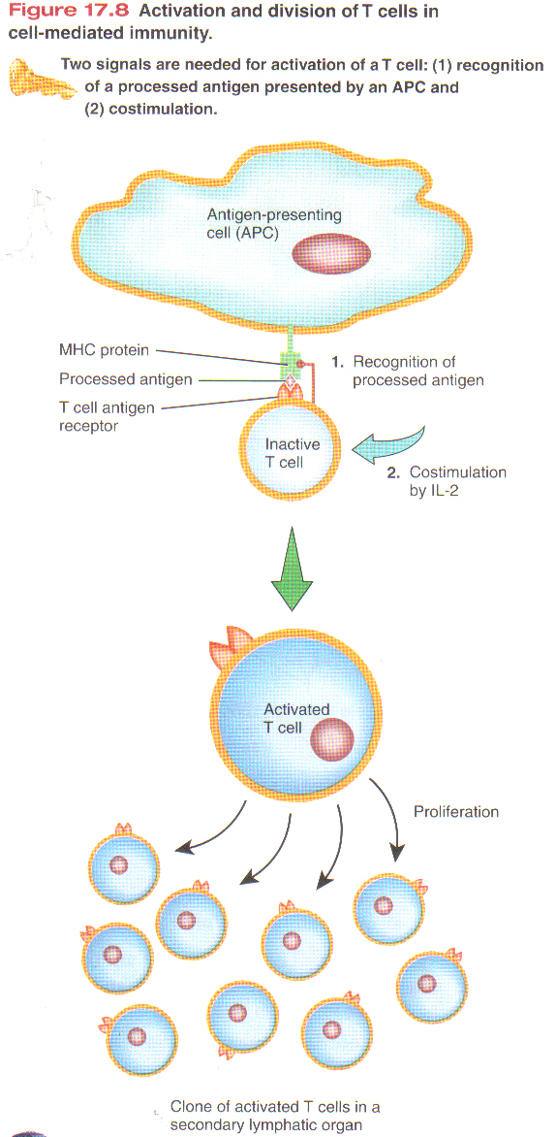
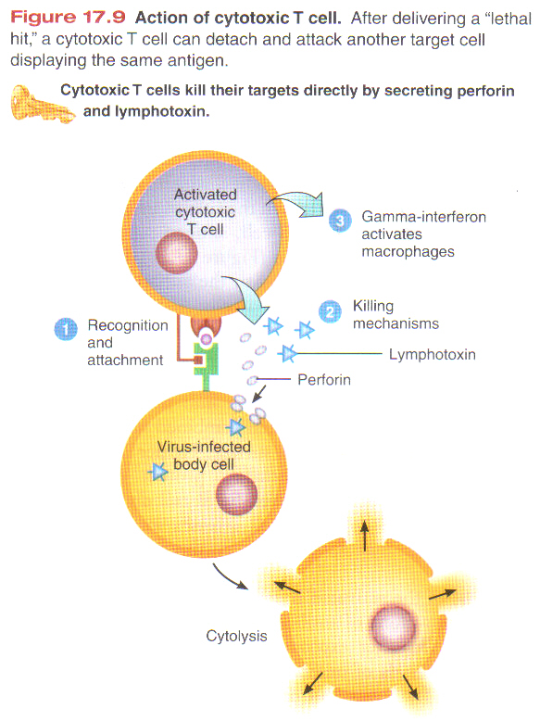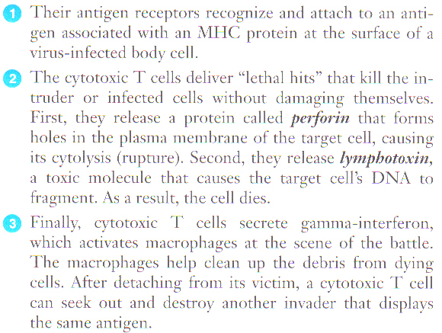

Types of T cells:
- Helper T cells: help other cells of the immune system: release interleukin-2; other proteins released attract phagocytes and enhance the phagocytic ability of macrophages; stimulate the development of B cells into antibody producing plasma cells.
- Cytotoxic T cells: cell-mediated immune responses- kill cells (especially cells infected by viruses, cancer cells associated with viral infection, and cells of a transplant. Leave lymphatic tissue eo seek out and destroy a foreign antigen.

- Memory T cells: remains in lymphatic tissue and recognizes original invading antigen

B cells and Antibody- Mediated Immunity
- In the presence of a foreign antigen, B cells in lymph nodes, the spleen, or lymphatic nodules become activated
  - Antigen receptors on the surface bind to antigen
  - Response is more intense when nearby APCs also process and present antigen to them
  - Helper T cells recognize APC and releases interleukin-2 and other proteins that function as costimulators to activate B cells
  - They divide and develop into plasma cells that secrete specific antibodies which circulate in the lymph and blood to reach the sites of invasion.
  - Some remain as memory B cells

Antibodies attack antigens in several ways:
- Neutralizing antigen: prevents attachment of some viruses to body cells
- Immobilizing bacteria: limits bacterial spread into nearby tissue
- Agglutinating antigen: clumps antigens together, making phagocytosis easier
- Activating complement
- Enhancing phagocytosis: antibody/antigen acts as “flag” that attracts phagocytes

Types of Immunity:
- Naturally Acquired Active Immunity: binding of antigen by B cells and T cells and costimulation lead to antibody-secreting plasma cells, cytotoxic T cells, memory B cells, and memory T cells
- Naturally Acquired Passive Immunity: Transfer of IgG antibodies from mother to fetus across the placenta, or of IgG antibodies from mother to baby in breast milk
- Artificially Acquired Active Immunity: antigens introduced during a vaccination stimulate cell-mediated and antibody-mediated immune responses, leading to the production of memory cells, the antigens are pretreated so they will trigger an immune response but not cause significant illness
- Artificially Acquired Passive Immunity: intravenous infection of immunoglobulins

Images from the “Introduction to the Human Body: the essentials of anatomy and physiology” Tortora & Grabowski

